DOWNTOWN ACTIVITIES & EVENTS
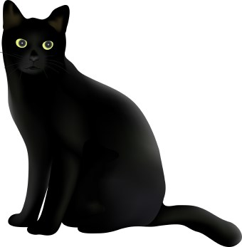 December 2019  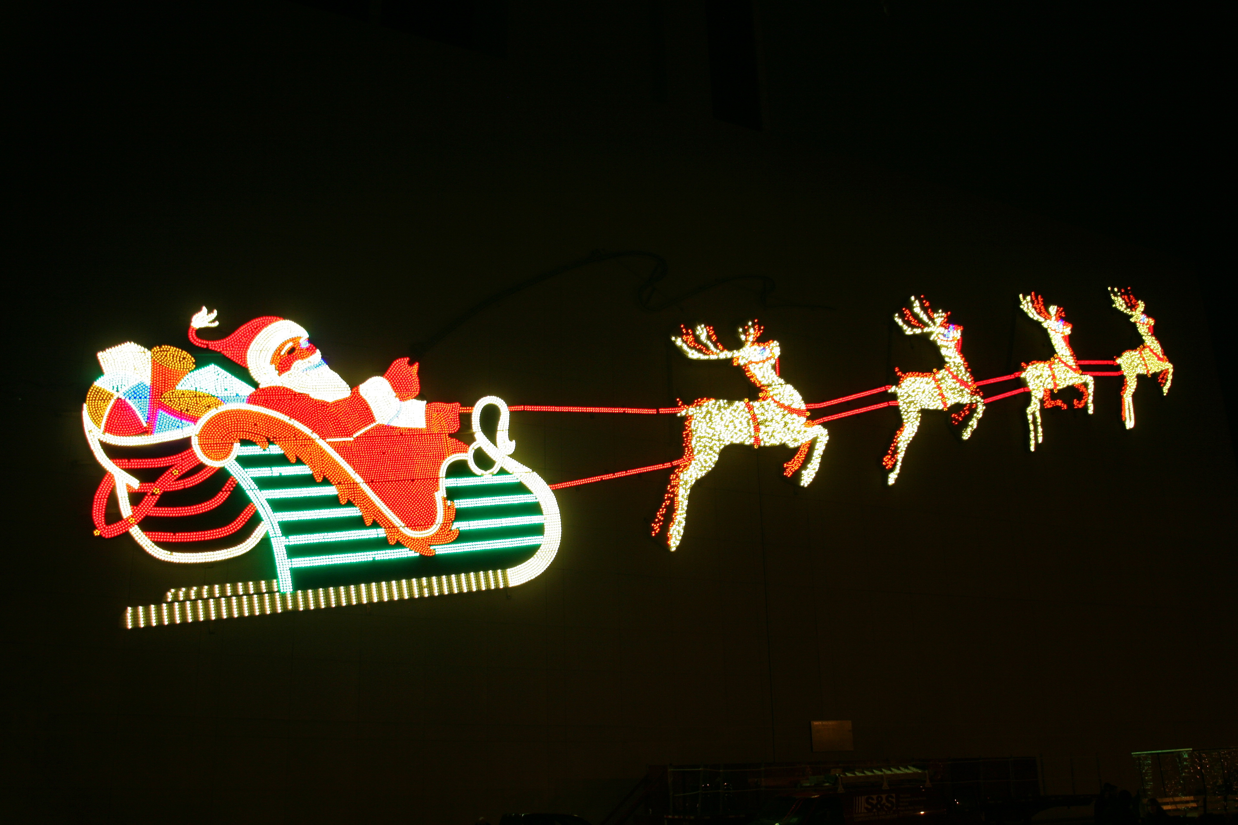
Northwest Pilot Project 1430 SW Broadway Suite 200 503-227-5605

Art in the Lobby Enjoy artwork by Betsy Carnes. Lobby hours Mon-Fri 9am-4pm
Looking for Senior Artists: If interested in displaying, please contact Wendy 503-478-6877.

Christmas Christmas Meals & Baskets: See resource list on enclosed flyer
Holiday Bazarr: Shop at the Bazarr held at Laurelhurst School (840 NE 41st Ave)
12/1 from 9am-4pm.
Gospel Natavity: Story by Langston Hughes retells the classic Nativity story with
holiday carols sung gospel style at Bethel AME Church (5828 NE 8th Ave) 12/1-12/15.
Lights at the Grotto: This Christmas Festival will have lights, choirs, carolers, a
petting zoo, puppet show & hot cocoa @ the Grotto (8840 NE Skidmore St).
12/1-12/30 (Closed 12/25) from 5-9:30pm & $11 tickets.
Drive-thru Light Show: Winter Wonderland has 250 displays of lights at the
Portland Raceways (1940 N. Victory Blvd) 12/1-1/4 open 5:30-9:30pm, $25 a car.
Pittock Mansion: Walk through the Pittock Mansion (3229 NW Pittock Dr) & enjoy
holiday decorations & music 12/1-1/5 & Closed 12/25, 10am-4pm. $12 tickets.
Zoo Lights: See the winter wonderland of lighted trees, animal silhouettes and
moving sculptures at the zoo (4001 CW Canyon Rd) 12/1-1/5 & Closed 12/25
from 5-9pm. $20 tickets.
Ship Parade: Watch 50 boats with Christmas lights cruise the Columbia &
Willamette River during the Christmas Ship Parade 12/5-12/22 (see enclosed flyer)
Tree Lighting: There will be a tree lighting ceremony plus music on Sat 12/7
at the following:
Alberta Main Street (1722 NE Alberta St) 4:30-6pm
Milwaukie (10722 SE Main) Tree lighting & umbrella parade@ 3:45pm
Oregon City (Liberty Plaza/Main St. between 8th & 9th) 4:30pm
West Linn (City Hall 22500 Salamo Rd) Fri. 12/6 from 6-8pm
Peacock Lane: Enjoy lighted houses 12/15-12/31 from 6-11pm.
Walk through “pedestrian only night” 12/15, 12/16 & 12/17 (see enclosed flyer)
Christmas Music: Enjoy a variety of Christmas music at the following:
Glory of Christmas: Repertory Singers, United Methodist Church,1838 SW Jefferson
12/8 @ 4pm, 12/13 @ 7:30pm & 12/19 @ 4pm. Tickets are $20-$40
Gospel Christmas: Gospel Chorus, Arlene Schnitzer Concert Hall
(909 SW Washington) 12/13 &12/14 @ 7:30pm & 12/15 @ 4pm (503-228-1353 tickets)
Home for the Holidays: Orchestra, Liberty High School (7445 NE Wagon Dr.)
In Hillsboro 12/18 @ 7:30pm

Pioneer Square Holidays at the Mall: Enjoy a variety of performances in the Square 12-1pm
12/3 Rose City Trombone
12/6 & 12/21 The Dickens Carolers
12/11 &12/22 The Beat Goes On Marching Band
12/15 Happenstance Quartet
12/16 Jazz Band, Wilson High

Christmas Carolers: Great Figgy Pudding Caroling Competition 12/13
from 5:30-7:30pm
Annual Tuba Christmas Concert 12/14 from 1-3:30pm
Nut Giveaway Enjoy roasted nuts 12/16 from 11:30am-12:30pm
Alameda Choir 12/18 from 5-6pm
Get A Life Marching Band 12/19 from 5-6pm
Power Pep Band 12/20 from 5-6pm
Photo Booth: Take a photo by the tree 12/20 from 4:30-6:30pm
Westby Flute Alliance: 12/21 from 11am-12pm

Events Cat Show: See 200 cats & 40 breeds at the Lewis & Clark Cat Show in the
Double Tree at the Lloyd Center 12/7 & 12/8

Old Church Noon Concerts: Concerts will be 12-1pm at The Old Church (1422 SW 11th Ave)
12/4 Martin Ellis, Organ & Linda Bergman, Flute
12/11 Diane Davies, Piano with Adam Eason, Cello
12/25 CLOSED

Art Portland Art Museum: 1219 SW Park Ave
Art & Conversation: Join the panel discussion with Samantha Springer 12/17, Kridel Ballroom, Mark Bldg.
Coffee @ 9:15am Mark Bldg, lecture @ 10am, Whitsell Auditorium Main Bldg (62+ yrs is free)
Photography Council: Bring lunch & join the discussion with
Brittney Cathey-Adams 12/18 from 12-1pm.
First Thursday: 12/5 Free admission to the museum 5-8pm.

Farmers Market PSU’s market is Saturdays from 9am-2pm.
The Market is located at PSU, S Park Blocks (between SW College & SW Montgomery).

PSU Flat Fix: Meet in the PSU HUB (1818 SW 6th Ave) 12-1pm 12/6, 12/13, 12/20, & 12/27

Food Market: The Oregon Food bank brings free fresh fruit, vegetables and other
food to PSU community. Arrive at 11:30am and sign up and get your color stick.
When your color is drawn you will move through the food line. Meet in the South
Park Blocks by Shattuck Hall from 11:30am -1:30pm on 12/9

Noon Concerts: The concerts will be in Lincoln Hall, Rm 75 from 12-1pm
12/5 Opera Workshop

Evening Concerts: The concerts will be in Lincoln Hall Rm 75
12/2 Jazz Band: Fall Concert @ 7pm
12/5 Wind Symphony & University Band Concert 7:30pm
12/8 Wind Symphony Holiday Concert 3pm
12/10 Opera Appreciation w/ Carl Halvorson 4pm

*ONGOING EVENTS IN THE COMMUNITY٭
Oregon Museum Oregon History Museum: The Oregon Historical Society educates, collects, & interprets Oregon history matters. Daily general admission is free for all Multnomah County Residents (proof of residency is required). Mon.-Sat. 10:00am–5:00pm.at
1200 SW Park Ave. Group reservations or any questions call 503-222-1741.
Downtown Chapel The following are free to the public and held at 601 West Burnside:
Art & Music Program: Monday, Wednesday, Friday, 10:00-11:30 a.m.
Express your creativity through art, music, puzzles, and games.

Foot Care: Wednesdays, 9:30-11:30 a.m. Get your feet pampered with massage, soaking and a free pair of socks.
Old Church Free Concerts: SW 11th and Clay, every Wednesday, 12:00 to 1:00 p.m.
Oregon Zoo $4 admission day: the second Tuesday of each month (503) 226-1561 ext. 0.
OMSI $2 admission day: the 1st Sun of ea. month 1945 SE Water Ave 9:30am-5:30pm
1st Baptist Church Downtown Fellowship Program: Free non-denominational, educational program or entertainment, followed by optional lunch (cost: $3) at Noon, and Bible study. SW 11th & Taylor, On the 2nd & 4th Thurs.10:30 a.m.-12:00 p.m.

